**IFT 266 Introduction to Network Information Communication Technology**

**Lab 10**

**Switch Configuration - Secure Shell (SSH)**   
  
Co-Authored by Michaela Pawlowski

**After you complete each step, put an ‘x’ in the completed box.**

**Objective**: Create a simple topology to configure and test an encrypted SSH connection.

1. Set up the following Packet Tracer topology.

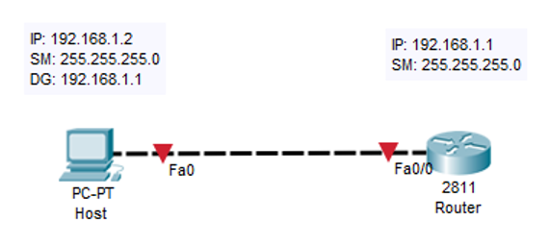



1. Navigate to the router’s CLI and enter the following commands.

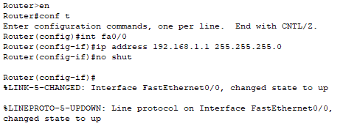



1. Configure the host’s IP address, subnet mask, and default gateway so that it can communicate with the router.



1. Verify that the host can talk to the router with a ping.



1. We will now configure SSH on our router. Navigate to the router’s CLI again and enter the following commands.

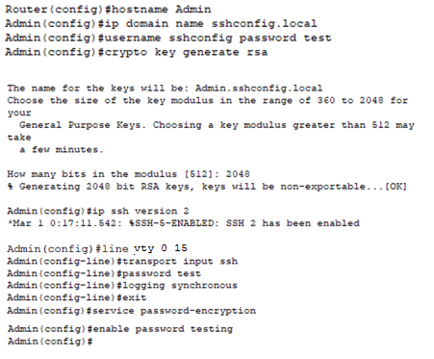



1. Now that our SSH configuration has been set up, we can test the connectivity. Enter the following command into the host’s command prompt. You will be prompted to enter the password you set earlier.  
     
    **Note on the command:** ssh – l (l for lima) ……..

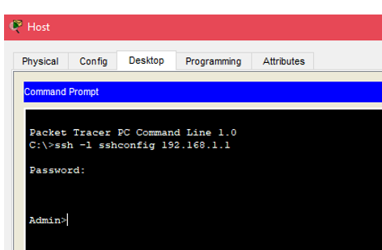



1. If you executed all steps successfully, you should see the router’s **Admin** prompt after entering your SSH password. If you can’t connect, troubleshoot!

**Attach a screenshot of your successful SSH connection!**